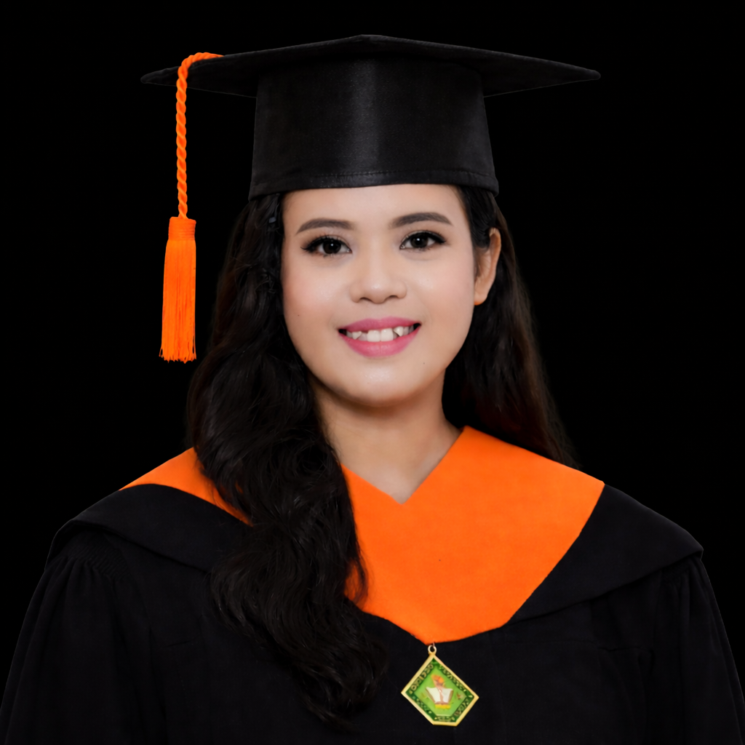
MARY GRACE PERION
Address: Punta 1, Tanza, Cavite, 4108
Email: Graceperion7@gmail.com
Phone Number: 0993-282-5093

Objectives
To work in an accounting role where I can apply my skills and knowledge, tackle new challenges, and advance my career while contributing to the company’s growth and success.

Work Experience

Accounting Staff – Triangelen Marketing Corporation (Sep 2021 – Jul 2024)
- Managed financial transactions, bookkeeping, and distribution records for Kopiko products.
- Assisted in preparation of reports for banking and financial services.
- Maintained accurate and organized accounting documentation.
Accounting Assistant – Force Central Field Distribution Inc. (Jan 2021 – Feb 2021)
- Support cost accounting and general finance activities.
Trainee – De La Salle Medical and Health Sciences Institute (Feb 2020 – Mar 2020)
- Provided clerical and administrative support in healthcare operations.
- Assisted in office documentation and filing systems.
Trainee – Provincial Government of Environmental and Natural Resources
(Jun 2017 – Jul 2017)
- Provided administrative support to human resources, streamlining employee documentation and HR processes.
- Assisted in organizing documentation and reports.
- Maintained organized office documentation and filing systems, improving efficiency and accessibility of records.

Education

Bachelor of Science in Office Administration
Cavite State University – Main Campus, CavSU Indang | Jun 2020
Certifications

- National Certificate III in Bookkeeping (2019)
- General Information Seminar (2019)

Skills

Technical Skills:
- Bookkeeping
- Accounts Payable / Accounts Receivable
- Financial Reporting
- Bank Reconciliation
- Payroll Processing
- Tax Preparation
Soft Skills:
- Attention to Detail
- Time Management
- Analytical Thinking
- Communication Skills
- Confidentiality Handling
  - Problem Solving & Adaptability
- Accounting Software
- Microsoft Excel, Word, PowerPoint

Achievements & Seminars

- Completed Internship at Provincial Government of Environmental Resources (2017)
- General Information Seminar (2019)
- Interacting with Professionals: Enhancing Leadership & Interpersonal Skills (2019)
- The Secret to Saving and Building Your Future (2019)

Reference

Jo Anne Nuestro – Professor / Department Head, Cavite State University
Phone Number: 0906-779-6615 | Email: iannicoledaniel123@gmail.com

